Assignment-1

Buğra Sarıkaya

17/01/2022

# Q1A:

## There are 20 characters who have at least one starship.

| name | ships | count |
| --- | --- | --- |
| Obi-Wan Kenobi | Jedi starfighter, Trade Federation cruiser, Naboo star skiff, Jedi Interceptor, Belbullab-22 starfighter | 5 |
| Anakin Skywalker | Trade Federation cruiser, Jedi Interceptor, Naboo fighter | 3 |
| Padmé Amidala | H-type Nubian yacht, Naboo star skiff, Naboo fighter | 3 |
| Luke Skywalker | X-wing, Imperial shuttle | 2 |
| Chewbacca | Millennium Falcon, Imperial shuttle | 2 |
| Han Solo | Millennium Falcon, Imperial shuttle | 2 |
| Darth Vader | TIE Advanced x1 | 1 |
| Biggs Darklighter | X-wing | 1 |
| Wedge Antilles | X-wing | 1 |
| Jek Tono Porkins | X-wing | 1 |
| Boba Fett | Slave 1 | 1 |
| Lando Calrissian | Millennium Falcon | 1 |
| Arvel Crynyd | A-wing | 1 |
| Nien Nunb | Millennium Falcon | 1 |
| Ric Olié | Naboo Royal Starship | 1 |
| Darth Maul | Scimitar | 1 |
| Plo Koon | Jedi starfighter | 1 |
| Gregar Typho | Naboo fighter | 1 |
| Grievous | Belbullab-22 starfighter | 1 |
| Poe Dameron | T-70 X-wing fighter | 1 |

# Q2A:

| eye_color | count |
| --- | --- |
| brown | 21 |
| blue | 19 |
| yellow | 11 |
| black | 10 |
| orange | 8 |
| red | 5 |
| hazel | 3 |
| unknown | 3 |
| blue-gray | 1 |
| dark | 1 |
| gold | 1 |
| green, yellow | 1 |
| pink | 1 |
| red, blue | 1 |
| white | 1 |

# Q3A:

| species | count | avg |
| --- | --- | --- |
| Yoda’s species | 1 | 896 |
| Hutt | 1 | 600 |
| Wookiee | 2 | 200 |

# Q4A:

| name | height | mass | hair_color | skin_color | eye_color | birth_year | sex | gender | homeworld | species | films | vehicles | starships |
| --- | --- | --- | --- | --- | --- | --- | --- | --- | --- | --- | --- | --- | --- |
| Buğra Sarıkaya | 170 | 60 | black | fair | brown | 26 | male | masculine | Dathomir | Human | Return of the Jedi | Tsmeu-6 personal wheel bike | Jedi Interceptor |

# Q5A:

| name | height | mass | hair_color | skin_color | eye_color | birth_year | sex | gender | homeworld | species | films | vehicles | starships | BMI | weight_status |
| --- | --- | --- | --- | --- | --- | --- | --- | --- | --- | --- | --- | --- | --- | --- | --- |
| Luke Skywalker | 172 | 77 | blond | fair | blue | 19 | male | masculine | Tatooine | Human | The Empire Strikes Back, Revenge of the Sith, Return of the Jedi, A New Hope, The Force Awakens | Snowspeeder, Imperial Speeder Bike | X-wing, Imperial shuttle | 26.02758 | overweight |
| C-3PO | 167 | 75 | NA | gold | yellow | 112 | none | masculine | Tatooine | Droid | The Empire Strikes Back, Attack of the Clones, The Phantom Menace, Revenge of the Sith, Return of the Jedi, A New Hope |  |  | 26.89232 | overweight |

# Q6A:

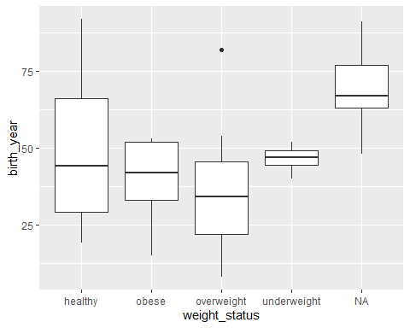

# Q7A:

